The Australian 22 Oct 2018

Naturalist Grace Thorsborne spent 60-plus years nursing coast back to life
By Phil Dickie
11:00PM October 21, 2018

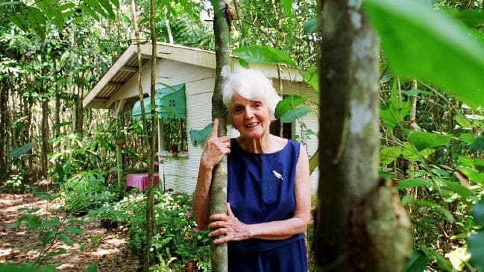Conservationist Margaret Thorsborne has died aged 91. Picture: Shae Beplate
Nurse-become-naturalist Margaret Grace Thorsborne spent more than six decades in the frontlines of coastal conservation in Queensland.
For the most part, her considerable successes extending the national park estate and protecting wildlife were gained through respectful submissions and courteous negotiations. But not always — she was also the tiny, white-haired woman standing in the way of a grand plan, and frequently the heavy machinery, of Keith Williams, the most brash of Queensland’s White Shoe Brigade generation of developers.
The resort marina of Port Hinchinbrook was the grand plan. “Poor Hinchinbrook” was Thorsborne’s riposte and in 1994 she and a companion were the first to take to the mangrove trees — in the area up to 13m tall — to hold the bulldozers at bay.
The dispute pitted a state Labor government against its federal Labor counterpart. In a night of high drama in Canberra, Brisbane and Cardwell, the federal government proclaimed a World Heritage area, conservationists quit the mangroves believing the battle won and Williams defiantly sent in the bulldozers anyway.
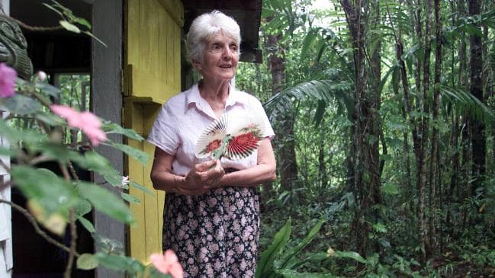Margaret at her home in the rainforest near Cardwell. Picture: Graham Crouch
Thorsborne suffered threats, writs and harassment. Port Hinchinbrook eventually went ahead as a much-diminished project, more housing estate than resort, after the Howard government relaxed some conditions.
For services to conservation, Thorsborne was made an officer of the Order of Australia on January 26, 2011. On the same day, a tropical low formed off Fiji and, as Cyclone Yasi, struck the Cardwell area three days later. It destroyed Thorsborne’s cottage deep in the rainforest, with newspaper reports also lamenting the loss of the chick of resident cassowary Poppa — once nominated as Queensland Father of the Year.
Also destroyed was the Port Hinchinbrook marina.
Thorsborne and her husband are also celebrated for a key role in saving the Torresian imperial pigeon, an iconic but unfortunately highly vulnerable bird that nests on offshore islands in northern Australia.
In 1606, Spanish explorer Luís Vaz de Torres had noted dense clouds of the pigeons flying between nesting islands and feeding sites on the mainland. By 1960, hunting, mainly of birds on their nests despite this being illegal since 1871, had put Torresian pigeons a long way down the road to extinction.
In 1965, the Thorsbornes sat back to back on the beach of North Brook Island off Cardwell and counted 4962 birds flying to the mainland in the first of what was to become Australia’s longest running bird count. In 1967, it was estimated hunters had killed an estimated 1100 birds on the island.
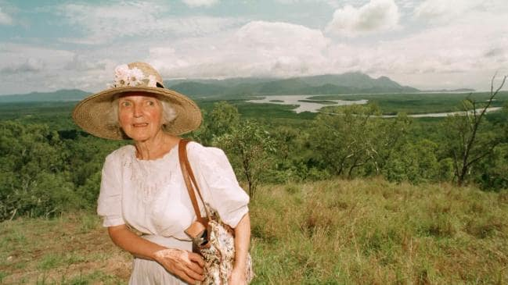Margaret Thorsborne, on top of Cardwell Range Lookout in 1997. Picture: Campbell Scott
In 1968, as the Thorsbornes approached the island, armed only with paper and pencils, they could hear the shooting. A party of hunters emerged from the bush and Arthur Thorsborne confiscated their guns, provoking intense arguments. The pigeon count for the year plummeted to just 1451.
But the confiscated shotguns supported the first prosecutions for shooting nesting birds, and large-scale hunting ended. By 1992, the count had reached 29,818 and, cyclones aside, it continues to fluctuate around this level.
Margaret and Arthur Thorsborne were early members of the Wildlife Preservation Society of Queensland and Margaret in 2001 succeeded noted poet and Great Barrier Reef protection advocate Judith Wright as patron.
“Margaret’s significant contributions to science and education arose from her own observations and records, from years of botanical specimen collecting, from practical support to scientists and students, and from funding for research projects,” noted WPSQ in its memorial article last week.
“Five species bear the Thorsborne name. This supportive, restorative and educational role was continued through the many activities of the Thorsborne Trust.”
The couple first visited the Hinchinbrook Island and Passage area in 1964, and fell in love with it, moving to live permanently on the banks of Meunga Creek in 1972. They were instrumental in the establishment of national parks to protect the natural values of the area, including the 1980 donation of 23ha of their own land to the Edmund Kennedy National Park.
The Thorsborne legacy lives on through Hinchinbrook: The Land Time Forgot, the definitive book on the area, and in the Thorsborne Trail, the world-renowned walking track running the length of Hinchinbrook Island

